1.1 HTML Tags

This section will guide you to:

* Implement different HTML tags

This guide has two subsections, namely:

1.1.1 Creating an HTML file

1.1.2 Pushing the code to GitHub repositories

**Step 1.1.1:** Creating an HTML file

* Create a text file with the name **Tags** and save it in **.html** format.
* Write the given code in the file.

<html>

<body>

<p>The below heading tags are written under paragraph tag

<h1>This is h1 heading</h1>

<h2>This is h2 heading</h2>

<h3>This is h3 heading</h3>

<h4>This is h4 heading</h4>

<h5>This is h5 heading</h5>

<h6>This is h6 heading</h6>

</p>

=================<br>

<a href="https://www.simplilearn.com">This is a link</a> <br>

=================<br>

<img src="https://encrypted-tbn0.gstatic.com/images?q=tbn:ANd9GcSpV93h9f0iWS_mBXQ_3TfYpN6XPv3aC2PJHue7t5cwkRxP-sCKrVxuxMXZfagCuQJyBWA&usqp=CAU" width="150" height="150"><br>

=================<br>

<button>Click me</button></h4><br>

=================<br>

<ul>

<li>Coffee</li>

<li>Tea</li>

<li>Milk</li>

</ul>

<h5>An Ordered HTML List</h5>

<ol>

<li>Coffee</li>

<li>Tea</li>

<li>Milk</li>

</ol>

</ul>

=================

<h2>Table and input</h2>

<table>

<tr>

<td><h3>Username:</h3></td>

<td><h3><input type="text"/></h3></td>

</tr>

<tr>

<td><h3>Password:</h3></td>

<td><h3><input type="password"/></h3></td>

</tr>

</table>

</body>

<html>

* Open the file in the browser and it should give the below output:

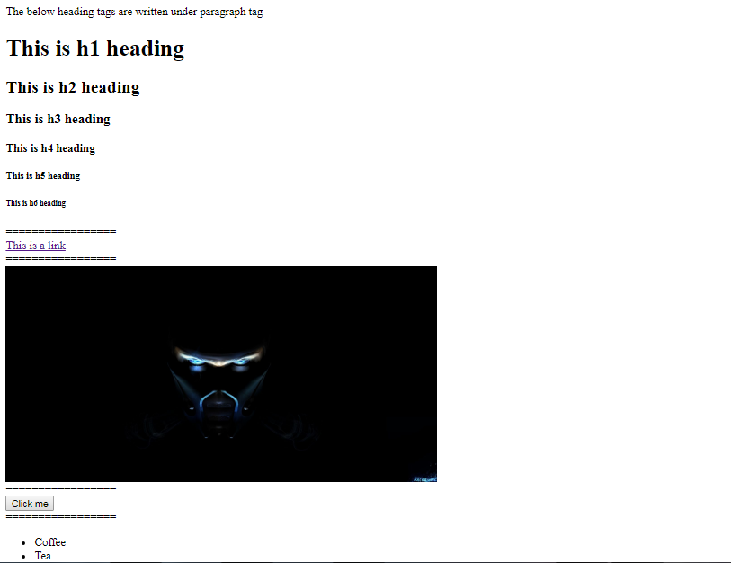

**Step 1.1.2:** Pushing the code to your GitHub repositories

Open your command prompt and navigate to the folder where you have created your files

cd <folder path>

Initialize your repository using the following command:

git init

Add all the files to your git repository using the following command:

git add .

Commit the changes using the following command:

git commit . -m “Changes have been committed.”

Push the files to the folder you initially created using the following command:

git push -u origin master